**AI-Based Resume Screening and Job Classification System**

**1. Project Overview (Introduction)**

In this project, I will create an AI model that automatically classifies resumes into predefined job categories based on the resume text. The model will use **Deep Learning (LSTM)** or **Transformers (BERT)** to understand the content and assign each resume to a specific job category. This system aims to assist recruiters by automating the initial resume screening process.

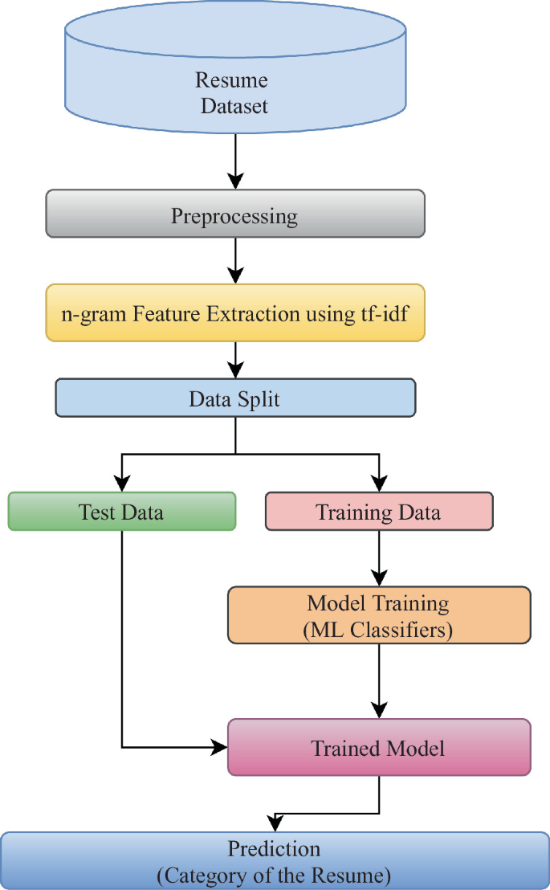

**2. Dataset Selection**

I will use the following dataset:  
✅ **Dataset Name:** Resume Dataset by Snehaan Bhawal  
✅ **Source:** [Kaggle - Resume Dataset](https://www.kaggle.com/datasets/snehaanbhawal/resume-dataset)  
✅ **Description:** This dataset contains over 2,400 resumes classified into different job categories like Data Scientist, Web Developer, HR, and more.

**3. Tools and Libraries**

| **Task** | **Tools/Libraries** |
| --- | --- |
| Data Preprocessing | Pandas, NLTK, Regex |
| Text Vectorization | TF-IDF or CountVectorizer |
| Model Training | TensorFlow, Keras, LSTM |
| Evaluation | Scikit-Learn |
| Visualization | Matplotlib, Seaborn |

**4. Step-by-Step Roadmap**

**✅ Week 1: Model Development**

| **Day** | **Task** | **Status** |
| --- | --- | --- |
| 1 | Searching for Datasets | **✅** Done |
| 1 | Dataset Download & Import | **✅** Done |
| 2-3 | Data Preprocessing (Cleaning Text, Removing Stopwords) | **✅** Done |
| 4 | Text Vectorization (TF-IDF or Word Embeddings) | **✅** Done |
| 5-6 | Build LSTM Model | **✅** Done |
| 7 | First Model Training | **✅** Done |

**✅ Week 2: Evaluation & Improvements**

| **Day** | **Task** | **Status** |
| --- | --- | --- |
| 8 | Model Evaluation (Accuracy, Precision, Recall) | **✅** Done |
| 9-10 | Hyperparameter Tuning | **✅** Done |
| 11 | Save Model & Build API | **✅** Done |
| 12 | Create Demo (Classify Custom Resumes) | **✅** Done |
| 13 | Final Testing | **✅** Done |
| 14 | Documentation | **✅** Done |

**2. Data Preprocessing**

**What Was Done:**

* **Data Loading:**
  + Loaded the resume dataset (CSV) containing columns such as ID, Resume_str, Resume_html, and Category.
  + Ensured that the relevant text column (Resume_str) was correctly identified and converted to string format.
* **Cleaning & Preprocessing Code:**
  + Developed a custom text cleaning function using Python’s regex and basic tokenization.
  + Steps included:
    - Converting text to lowercase.
    - Removing HTML tags.
    - Eliminating special characters and numbers.
    - Splitting text into tokens.
    - Removing a basic set of stopwords.
  + Saved the cleaned resumes to a new CSV file (cleaned_resume_processed.csv).

**3. Text Vectorization**

**What Was Done:**

* **Word Embeddings with Gensim:**
  + Loaded pre-trained GloVe embeddings (50-dimensional) using Gensim.
  + Developed a function to calculate the average embedding for each resume.

**4. LSTM Model Building**

**What Was Done:**

* **Data Preparation for LSTM:**
  + Tokenized the cleaned text using Keras’ Tokenizer and padded sequences to a uniform length.
  + Converted the job categories into one-hot encoded vectors using LabelEncoder and Keras’ to_categorical.
* **Model Architecture:**
  + Built an LSTM model using TensorFlow/Keras:
    - **Embedding Layer:**  
      Initialized with the pre-trained GloVe embedding matrix (embeddings kept fixed during training).
    - **LSTM Layer:**  
      Used 64 LSTM units with dropout for regularization.
    - **Dense Layer:**  
      Final output layer with softmax activation for multi-class classification.
  + Compiled the model with categorical cross-entropy loss and the Adam optimizer.

**5. Model Training**

**What Was Done:**

* Trained the LSTM model on the preprocessed data.
* Set training parameters:
  + **Epochs:** 10-200
  + **Batch Size:** 32
  + **Validation Split:** 20% of the training data was used for validation.

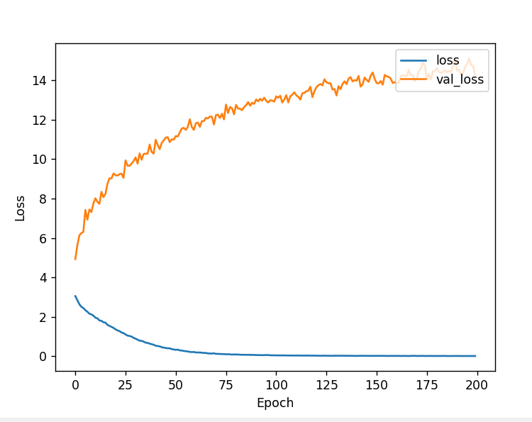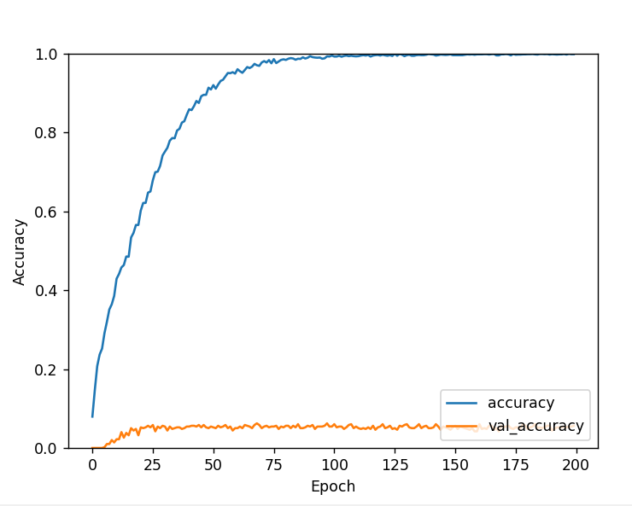

* Saved the trained model for future evaluation and deployment.

**6. Model Evaluation and Hyperparameter Tuning**

**What Was Done:**

* **Evaluation:**
  + Split the dataset into training and test sets.
  + Evaluated the model using metrics such as **accuracy**, **precision**, and **recall**.
  + Generated a detailed classification report to assess performance across different classes.
* **Hyperparameter Tuning:**
  + Implemented hyperparameter tuning using **Keras Tuner (RandomSearch)**.
  + Tuned key parameters like:
    - Number of LSTM units.
    - Dropout and recurrent dropout rates.
  + Built and retrained the best model configuration based on validation accuracy.

**Learned:**

* The value of using tools like **Keras Tuner** to automate the search for optimal hyperparameters.

**7. Next Steps**

* **Further Model Evaluation:**  
  Refine the evaluation process with additional metrics (e.g., F1-score) or cross-validation.
* **Model Deployment:**  
  Explore building a user interface (using Flask or Streamlit) to showcase model predictions.
* **Fine-Tuning:**  
  Consider fine-tuning the embeddings or adjusting model architecture further based on additional experiments.

**8. Testing on New Data**

* **PDF Resume Testing:**
  + Implemented code to extract text from PDF files using pdfplumber.
  + Integrated text preprocessing, tokenization, and padding pipelines to convert new resume data into the appropriate format.
  + Loaded the saved model and ran predictions on new data.
  + Visualized the prediction confidence and distribution using bar charts.
* **Outcome:**
  + Demonstrated the end-to-end functionality of the system on unseen data.

**What Was Learned**

* **Data Preprocessing:**
  + The importance of clean and consistent text data for NLP.
* **Feature Extraction & Vectorization:**
  + How pre-trained word embeddings (like GloVe) can be used to capture semantic meaning in text.
  + Converting variable-length resumes into fixed-length representations.
* **Model Development:**
  + Building and training LSTM models for sequence classification.
  + The value of dropout and proper architecture design in preventing overfitting.
* **Hyperparameter Tuning:**
  + Setting up a search space for hyperparameters using Keras Tuner.
  + Evaluating model performance under different configurations to determine optimal settings.
* **Deployment & Testing:**
  + How to integrate additional data sources (e.g., PDFs) into your pipeline.
  + The process of extracting text from PDFs and converting it for model prediction.

**9. Next Steps**

* **Model Refinement:**
  + Further fine-tune the hyperparameters based on tuning insights.
  + Possibly retrain the model on a more balanced or larger dataset if needed.
* **Final Report:**
  + Compile these findings, challenges, and improvements into a final project report.
  + Include visualizations (training curves, hyperparameter tuning graphs, prediction confidence charts) as supporting evidence.